EXTINCT?:
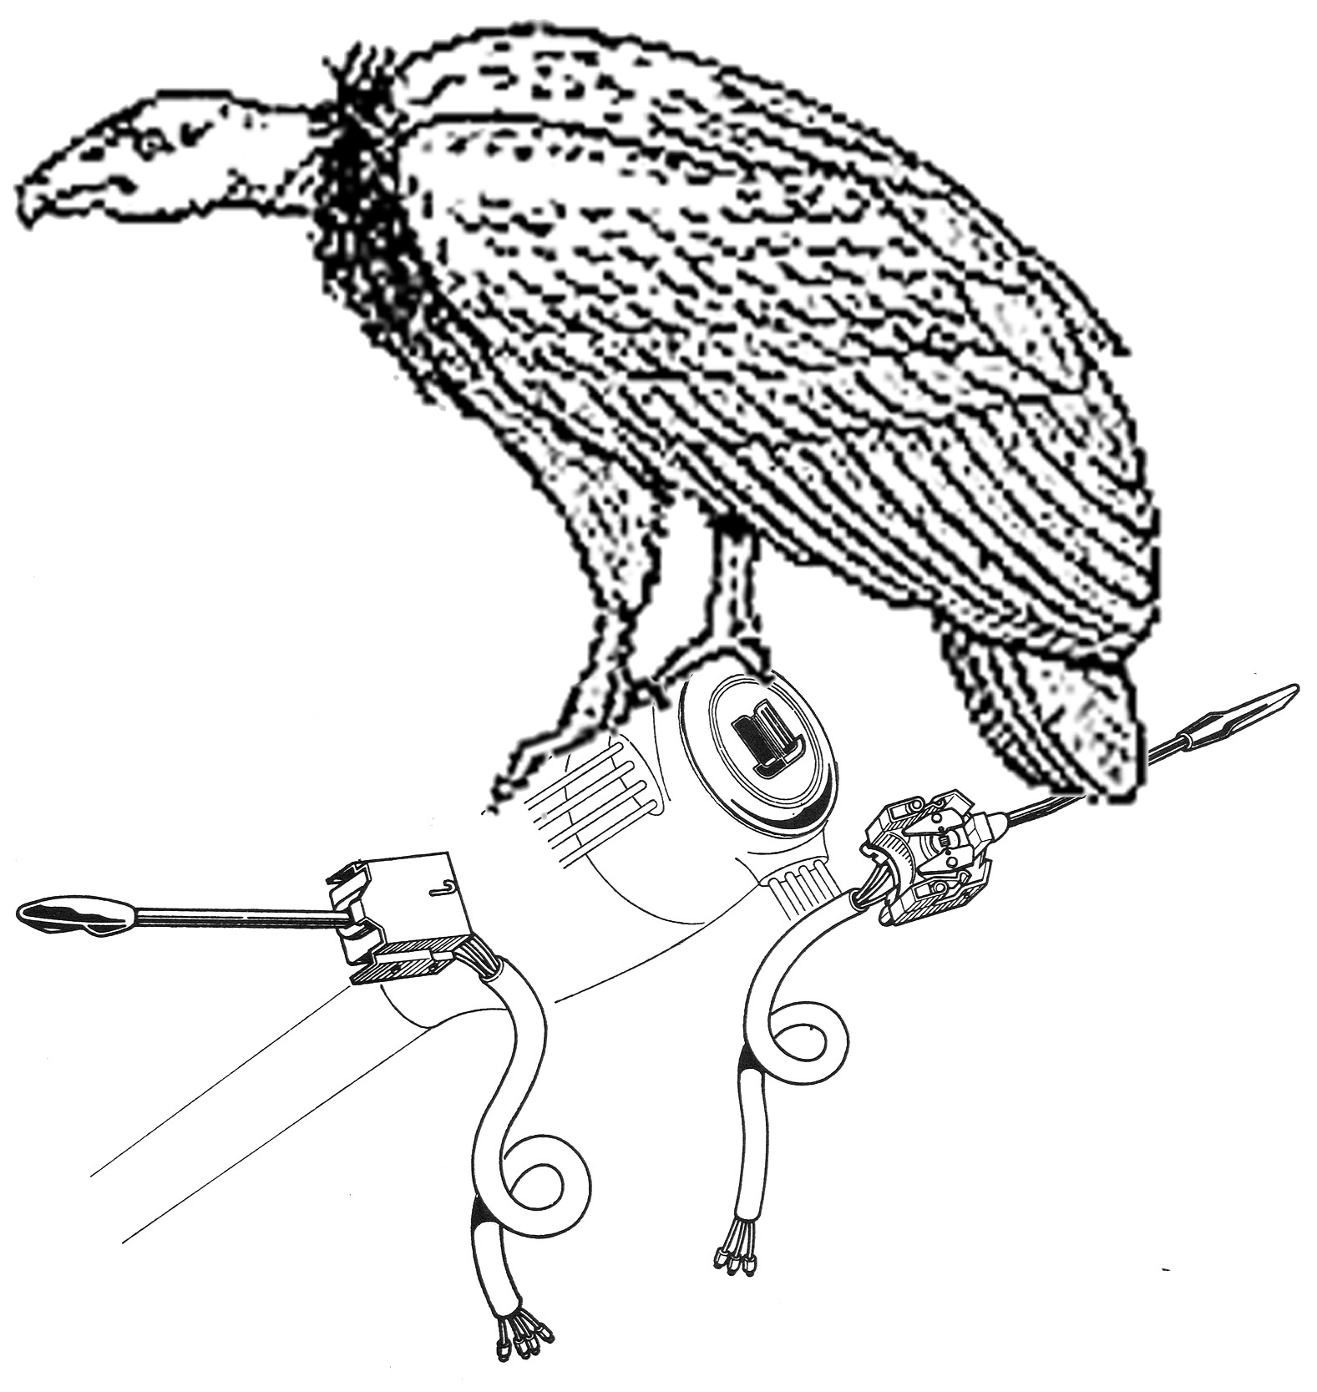
SAVING THE LUCAS CHROME LIGHTING & NLS TRAFFICATOR SWITCHES

By Justin Wagner
As rare and hard to find as the endangered California condor, I looked high and low for a replacement chrome trafficator (turn signal) for my Triumph. I finally found a new “old stock” switch on Ebay, jumped on it, won the auction, and paid a ridiculous amount of money for it. Afterward, I had major buyer’s remorse. The switches in my Triumph TR 4A worked fine. The lighting switch was an original switch, but with flaking chrome, the trafficator was a replacement switch, that was black. Did I really need to be spending so much money, not to mention the ridiculous labor of installing the new switch, just to restore a little chrome to the dash? The answer was “NO!”. I had a brainstorm: Thanks to now Governor Arnold Schwarzeneggar, I had the answer all along.

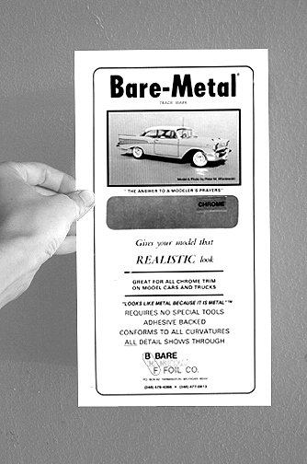
Actually, the answer came from working on “Batman”, starring Arnold, where I used a product called “Bare-Metal Foil” on one of the props in the movie. Basically, it’s a metal foil with a sticky back. It’s marketed to model makers for making chrome parts on models look much more “real” than any silver paint job.

It’s actually very simple to use and it can all be done on the car, without removing the switch, but it does help to remove the plastic steering column covers. If you goof up, it’s easy to strip it off with your fingernails and try again (as long as you don’t wait a long time). The first order of business is to prepare the switch. The foil is very thin: the positive is that seams aren’t very visible and there’s no material resistance trying to undue your efforts; the negative is that it will transfer any underlying details to the surface! This is great for modelers, as details cast into the plastic models are not lost, but in this application, you certainly don’t want pits to be seen on the “new” surface.

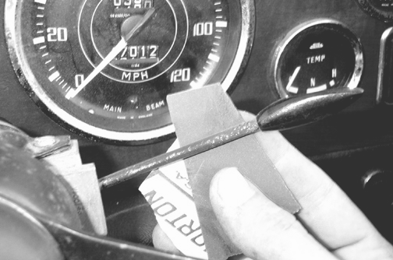
On my car, I decided to just fly through it so I did not go overboard on preparing the stems. I did sand them, but I did not fill the rust pits. I suggest you take the time to fill pits and sand them smooth. You can use body working techniques, filling imperfections with Evercoat™ “Polyester Glazing Putty” or any other automotive 2-part body filler like “Bondo”. Sand the surface smooth, eventually finishing up with 600 grit or finer.
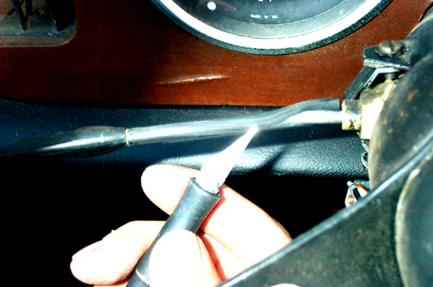
You will find some switches are chrome, some are painted black over unchromed metal, and some are covered with a black rubber tube over unchromed metal. If you find you have the rubber tube type, you should cut it away and prep the metal underneath. If you’re lucky, the rubber tube protected the metal and there won’t be any rust pits underneath. I used an X-acto knife to carefully cut it away. Besides being careful not to cut yourself, try not to scratch the metal either, as a scratch could transfer to the foil covering. After prepping the switches, it’s time to measure out the foil.

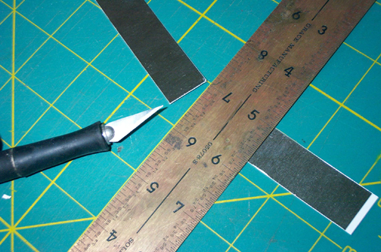
First, you need to measure a length, from the beginning of the switch out to the black knob. Secondly, you need to measure the circumference. I simply twisted a small strip of paper around the rod and marked the overlap with a pencil and then unravel it to measure the length of the circumference. You will want to cut the foil at the exact length, plus a little extra to allow the foil to overlap at the seam. I went for ¾” wide, and this turned out to provide much more overlap than I would have liked. You might go for a little less, but check your switch, the circumference could be different. Just shoot for about a 1/16” overlap.

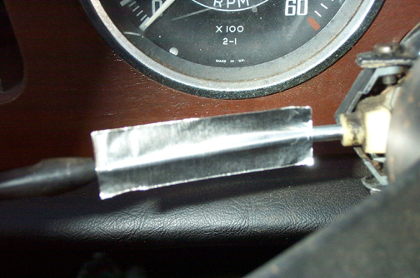
I noticed some switches are nearly straight, and others have a bend in them. It is difficult to get the foil to lay down cleanly on a sharp bend. On the switches with a bend, I recommend two steps: wrap a shorter piece from the column side out to just beyond the center of the bend. Then cut your next piece to reach from the end of the knob to just beyond the same center point to allow for a small overlap when it’s installed. You will end up with a visible line, but it is much cleaner than wrinkled or torn foil. (The photo here shows the smaller section already laid down and the longer section ready to lay down.) Theoretically, you can work the foil around curves and not have wrinkles, but it may be beyond most people’s skill level. You can certainly try using the directions that come with the product. If it doesn’t work for you, scratch it off and try again!

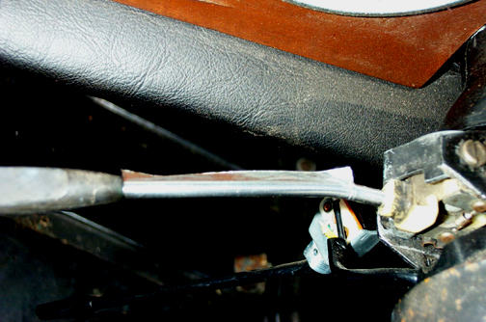
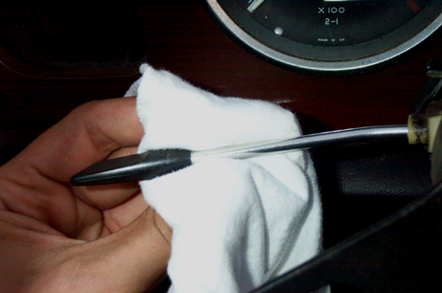
When you have your pieces ready to go, wipe off the stems with something like alcohol and peal back the paper backing on the piece you are working with. In the case of a stem with a bend, install the little piece first, and then follow with the longer. As shown in the pictures, what you want to do is carefully put the foil in place along a straight edge in such an orientation that when you fold it around, the resulting seam will be out of sight. Attach it parallel to the stem, square and flush against the knob. When you have it positioned, rub your finger lightly across the center so it looks roughly as it does in the picture. Then slowly lay down the bottom part by rubbing it down from the center out (to keep out wrinkles and air). Then work the other half back over the top of the rod and smooth it down along the bottom rear where it will overlap the other end.

You then burnish the foil down with your finger or a very soft cloth like a diaper or flannel gun cleaning patch, etc. (You don’t want to scratch the foil surface.) The final touch is to polish the foil with a fine metal polish. Once again, only use an applicator that will not scratch and lightly buff it down with the cloth.

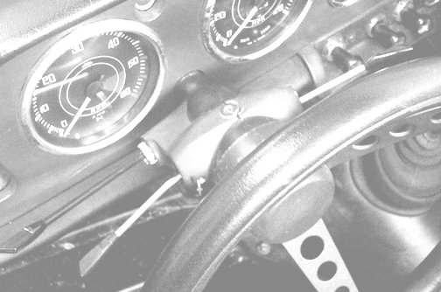
If you make a mistake, as mentioned, you can scrape it off with your fingernail. However, the adhesive will grow stronger in time, subsequently, if you wait, it will become increasingly difficult to get off. In time it can result in a struggle to get off even a little at a time and having to clean off the dry adhesive before you can try again. The adhesive makes a very tight bond and I doubt you will ever find that it comes loose. The surface will not look as good as real chrome, but it will be quite an improvement over “incorrect” later type black or badly pitted chrome stems. If, down the road, it becomes damaged, you can just do the process again!

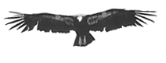
Factoid: Condors, the largest flying birds in North America, are now on the endangered species list. In 1982, there were fewer than 25 left in the wild. Today, their numbers have increased to approximately 200. Exactly how many new, “old stock” Lucas chrome trafficators still exist, lying on dusty shelves, all over the world, is unknown; hopefully their numbers will recover when someone like Moss or RF convinces Lucas to make a run of them.

To find the product near you, contact:
© Justin Wagner 1/04
Available for reprint by
permission only…just ask!

jmwagner@greenheart.com

Bare Metal Foil Company
P.O. Box 82
Farmington, Michigan 48332
(248) 476-4366 (248) 477-0813

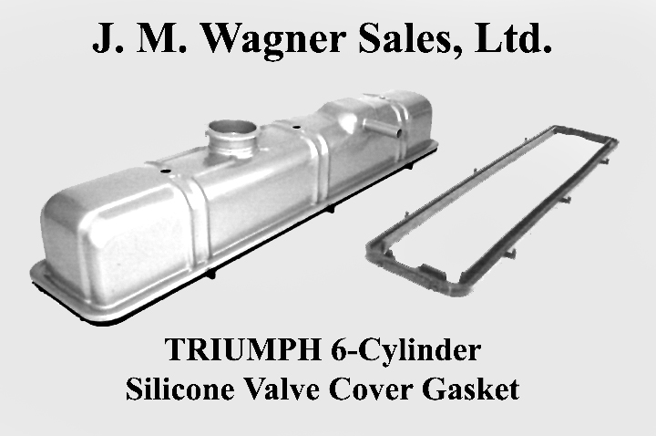
Let me know if you were pleased with the results! --Justin

Please visit my website and check out the new T6 gasket!
jmwagnersales.com

